

AI Smart Medicine Management System

Project Report

Submitted by

Name – Anjali Kumari
UID – 25MCA20023
Section – 25MCA1A

in partial fulfilment for the award of the degree of
Master of Computer Application



Chandigarh University

Declaration

I hereby declare that the project report entitled “AI Smart Medicine Management System” submitted in partial fulfilment of the requirements for the degree of Master in Computer Application is my original work and has not been submitted previously to any other institution or university for any degree or diploma.
I have carried out the work presented in this project report under the guidance of Shruti Sharma Ma’am. All the work presented here is genuine to the best of my knowledge, and any reference used has been appropriately acknowledged.
I am fully responsible for the authenticity of the content and any inaccuracies in the report

Acknowledgement
I would like to express my sincere gratitude to everyone who has contributed to the successful completion of this project on the AI Smart Medicine Management System in Advance Internet Programming (AIP).
First and foremost, I am deeply grateful to my instructor, Shruti Sharma Ma’am, whose continuous guidance, valuable insights, and unwavering support have been instrumental throughout the development of this project. Her expert advice and suggestions helped me understand the core concepts of web development, database management, and their real-world applications.
I would also like to thank my friends, family, and colleagues for their constant encouragement and moral support during this journey. Their motivation kept me focused and dedicated to successfully completing this project.
Lastly, I would like to acknowledge the contribution of various online resources, tutorials, and technical documentation that provided the necessary knowledge and guidance to implement this project effectively.
This project has been a valuable learning experience, enabling me to bridge the gap between theoretical knowledge and practical implementation in the field of web-based application development.

Anjalikumari

Table of Content

- Introduction
- Objective of AI Smart Medicine Management System
- Software and Hardware requirements
- Implementation.
- Key functionalities.
- Result.
- Output.
- Screenshots.
- Conclusion.
- References.

Introduction

The AI Smart Medicine Management System
is a web-based application designed to assist in the management and care of elderly individuals by automating essential daily activities such as medicine tracking, scheduling reminders, translation support, and purchase management. In today’s fast-paced digital world, ensuring proper care and timely assistance for elderly people has become increasingly important. This system aims to provide a reliable and efficient solution to support both caregivers and elderly users.
The application is developed using modern web technologies including JSP, Servlets, and MySQL database to ensure smooth functionality and data management. It offers multiple modules such as user registration and login, medicine management, reminder scheduling, language translation, and purchase tracking, all integrated into a single dashboard for ease of use.
The system enhances user experience by providing a simple, user-friendly interface that allows users to manage their daily healthcare activities effectively. It also ensures better organization and accessibility of important information, thereby improving overall efficiency and reliability.
This project includes source code, configuration files, and documentation that demonstrate the system architecture and working. By leveraging technology, the ElderCare Companion System helps bridge the gap between traditional caregiving and modern digital solutions, ultimately improving the quality of life for elderly individuals.

Objectives of the ElderCare Companion System

The primary objectives of the ElderCare Companion System are:
• Automation: To automate essential daily healthcare activities such as medicine management, scheduling reminders, and purchase tracking, thereby reducing manual effort and minimizing errors.
• User Accessibility: To provide a simple and user-friendly interface that allows elderly users and caregivers to easily navigate and manage different functionalities like medicine details, reminders, translation, and purchases.
• Data Security: To ensure that user data is securely stored in the database and protected from unauthorized access through proper authentication and session management techniques.
• Reminder Management: To help users set and manage reminders for medicines and daily activities, ensuring timely notifications and better health management.
• Multi-Function Integration: To integrate multiple features such as medicine tracking, scheduling, translation, and purchasing into a single unified dashboard for ease of use.
• Efficient Data Management: To maintain and organize all user-related data systematically using a database, enabling quick access and better performance of the system.
• Improved Quality of Life: To support elderly individuals in managing their daily routines more effectively, thereby enhancing their independence and overall well-being.

Software Requirements:

The following software and tools were used for the development and execution of the ElderCare Companion System:
• Operating System: The system can run on various operating systems such as Windows and Linux, providing flexibility and ease of deployment.
• Programming Language: The application is developed using Java, along with JSP (Java Server Pages) and Servlets, which provide a robust platform for building dynamic web applications.
• Database: A relational database management system (MySQL) is used to store user data, medicine details, schedules, and purchase records securely and efficiently.
• Integrated Development Environment (IDE): The project is developed using NetBeans IDE, which provides tools for coding, debugging, and project management.
• Web Server: Apache Tomcat is used as the application server to deploy and run the web application.
• Frontend Technologies: HTML, CSS, and Bootstrap are used to design a user-friendly and responsive interface.
• Additional Tools: XAMPP is used for managing the MySQL database and phpMyAdmin for database administration.

Hardware Requirements

- Processor: A minimum processor speed of 1 GHz is recommended to ensure smooth operation of the application.

- RAM: At least 2 GB of RAM is required to run the application effectively, especially when handling multiple transactions simultaneously.
- Hard Disk: A minimum of 500 MB of free space is necessary to accommodate the application files, database, and any additional resources.
These requirements provide a balanced environment for developing and deploying a Eldercare Companion System using Netbeans. Depending on the project's complexity and scale, you may adjust them, especially for larger databases or more intensive data processing tasks

Implementation

Overview of the ElderCare Companion System
The ElderCare Companion System is a web-based application designed to assist elderly individuals and caregivers in managing daily healthcare activities such as medicine tracking, scheduling reminders, translation support, and purchase management. The system is developed using JSP and Servlets for the frontend and backend, and it connects to a MySQL database for efficient data storage and retrieval.

Module Descriptions and Interactions

1. Login Module (LoginServlet)
• Purpose: Handles user authentication.
• Functionality:
• Displays login interface for username and password.
• Validates credentials using the database.
• On successful login, redirects to the dashboard page.
• Allows users to access the system securely.

2. Register Module (RegisterServlet)
• Purpose: Manages user registration.
• Functionality:
• Collects user details such as username and password.
• Stores user data in the database.
• Redirects user to login or dashboard after successful registration.

3. Dashboard Module (dashboard.jsp)
• Purpose: Serves as the main interface after login.
• Functionality:
• Provides navigation to all modules like Medicine, Schedule, Translate, and Purchase.
• Acts as the central control panel for the system.

4. Medicine Module (MedicineServlet & medicine.jsp)
• Purpose: Manages medicine details.
• Functionality:
• Allows users to add medicine name and dosage.
• Stores data in the database.
• Displays list of medicines on the same page.

5. Schedule Module (ScheduleServlet & schedule.jsp)
• Purpose: Handles reminder scheduling.
• Functionality:
• Allows users to set time-based reminders.
• Stores reminder data in the database.
• Helps ensure timely medicine intake.

6. Translation Module (TranslationServlet & translate.jsp)
• Purpose: Provides language translation support.
• Functionality:
• Accepts user input text.
• Converts it into another language (basic logic/API-based).
• Displays translated output to assist communication.

7. Purchase Module (PurchaseServlet & purchase.jsp)
• Purpose: Manages medicine purchases.
• Functionality:
• Allows users to select medicines and enter quantity.
• Stores purchase records in the database.
• Helps track medical expenses.

8. Notification Module
• Purpose: Provides alerts for scheduled activities.
• Functionality:
• Checks reminder time stored in database.
• Displays notifications or alerts to the user.
• Ensures timely actions.

9. Database Connection (DBConnection Class)
• Purpose: Manages database connectivity.
• Functionality:
• Establishes connection with MySQL database.
• Executes SQL queries for all modules.
• Ensures smooth data flow across the application.

User Flow in the System
- User Registration:
New users register by entering their details, which are stored in the database.
- User Login:
Registered users log in using their credentials. Upon successful authentication, they are redirected to the dashboard.
- Dashboard Access:
The dashboard provides access to all modules including medicine management, scheduling, translation, and purchase.
- Module Operations:
Users can add medicines, set reminders, translate text, and manage purchases as per their needs.
- Data Management:
All data is securely stored and retrieved from the MySQL database, ensuring consistency and reliability.

This implementation demonstrates how web technologies can be effectively used to create a user-friendly and functional healthcare support system for elderly individuals.

Overview of the Database Implementation
The ElderCare Companion System database is designed to efficiently manage user information, medicine records, schedules, purchases, and notifications. The system uses a MySQL database with multiple related tables to ensure proper data organization, consistency, and security.

Database Flow in the System
- User Registration & Login:
User data is stored in the user table and verified during login.
- Medicine Management:
Users add medicines which are stored in the medicine table.
- Scheduling Reminders:
Reminder data is stored in the schedule table and used for notifications.
- Purchase Tracking:
All purchase details are saved in the purchase table.
- Notifications:
Alerts are generated based on schedule data and stored in the notification table.

Table Descriptions and Relationships

1. user Table
• Purpose: Stores registered user details.
• Fields:
• id (Primary Key)
• username
• password
• Usage:
This table is used during user registration and login authentication. Each user is uniquely identified by their ID.

2. medicine Table
• Purpose: Stores medicine-related information.
• Fields:
• id (Primary Key)
• user_id (Foreign Key)
• medicine_name
• dosage
• Usage:
Stores the list of medicines added by users. Each record is linked to a specific user.

3. schedule Table
• Purpose: Manages reminder schedules.
• Fields:
• id (Primary Key)
• user_id (Foreign Key)
• reminder_time
• description
• Usage:
Used to store time-based reminders for medicines or other activities.

4. purchase Table
• Purpose: Tracks medicine purchases.
• Fields:
• id (Primary Key)
• user_id (Foreign Key)
• medicine_name
• quantity
• purchase_date
• Usage:
Maintains records of medicines purchased by users, helping in tracking expenses.

5. notification Table
• Purpose: Stores alert and notification data.
• Fields:
• id (Primary Key)
• user_id (Foreign Key)
• message
• notification_time
• Usage:
Used to generate alerts for scheduled reminders and important updates.

Relationships Between Tables
• The user table is the central table.
• All other tables (medicine, schedule, purchase, notification) are linked using user_id as a foreign key.
• This ensures that each user can manage their own data independently.

Flow char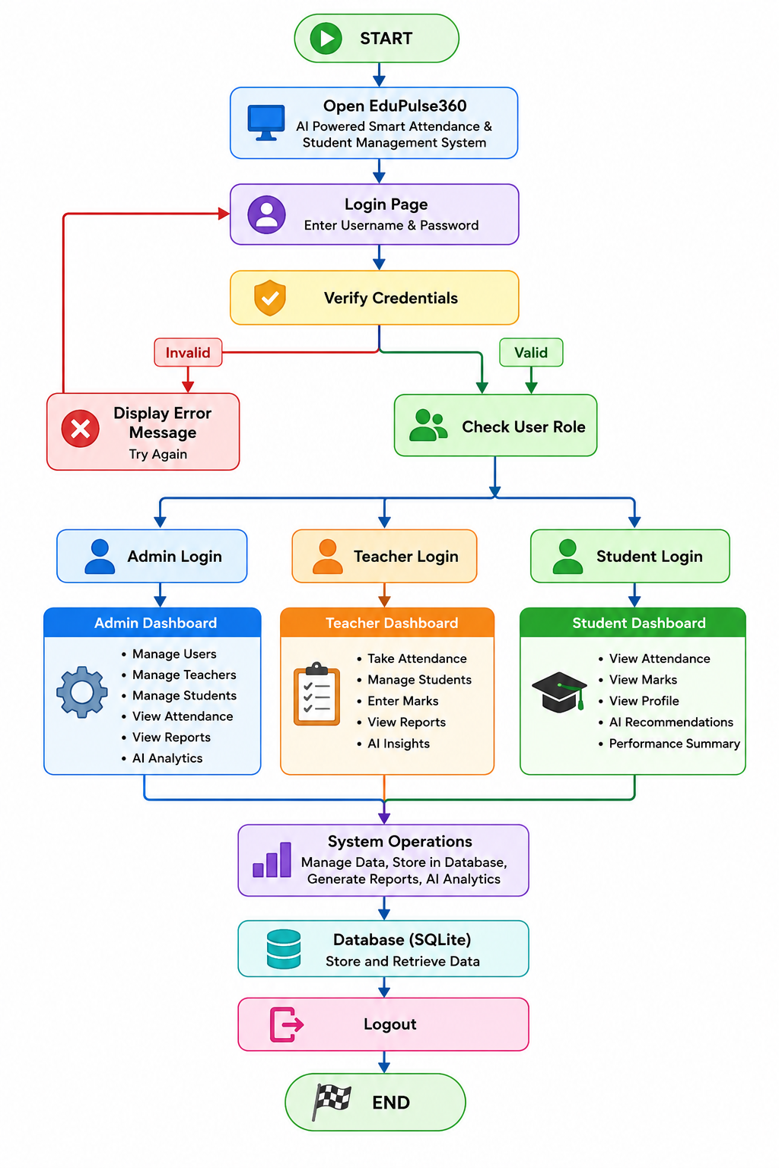

Key Functionalities of the ElderCare Companion System

1. User Login
• Users enter their username and password to log in.
• Credentials are verified using data stored in the MySQL database.
• Upon successful authentication, users are redirected to the dashboard.
• Ensures secure access through proper session management.

2. User Registration (Signup)
• Allows new users to create an account.
• Collects essential details such as username and password.
• Stores user information securely in the database.
• Enables users to log in later using registered credentials.

3. Dashboard (Main Interface)
• Acts as the central interface after successful login.
• Provides access to all major features of the system:
o Medicine Management
o Schedule/Reminder
o Translation
o Purchase
o Notifications
• Serves as the control panel for navigation.

4. Medicine Management
• Allows users to add medicine details such as name and dosage.
• Displays a list of added medicines.
• Helps users efficiently manage their medications.

5. Schedule & Reminder
• Enables users to set reminders for medicines or daily activities.
• Stores reminder time and description in the database.
• Ensures timely medication and routine management.

6. Translation Feature
• Allows users to input text and translate it into another language.
• Helps elderly users understand information easily.
• Enhances accessibility and communication.

7. Purchase Management
• Allows users to record medicine purchases.
• Stores details such as medicine name, quantity, and purchase date.
• Helps in tracking expenses and purchase history.

8. Notification System
• Generates alerts based on scheduled reminders.
• Displays important notifications to users.
• Ensures that no critical activity is missed.

9. Logout Functionality
• Allows users to securely log out of the system.
• Terminates the session and protects user data.

These functionalities collectively make the ElderCare Companion System a comprehensive, user-friendly, and efficient healthcare support solution for elderly individuals.

Output and screenshots

- Neatbeans Output

- Login/Register Class:
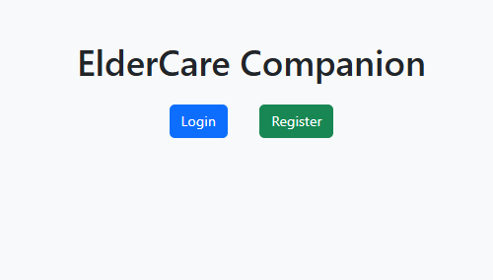

- Dashboard Class:
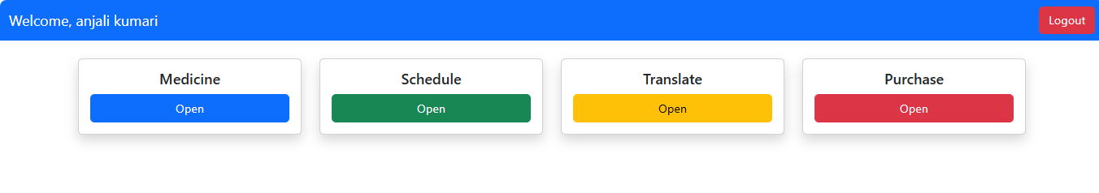

3.Medicine Class
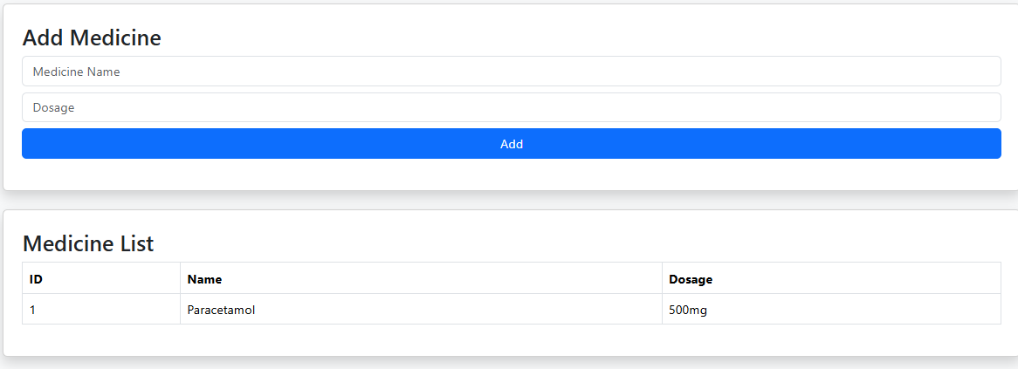

4.Set schedule:

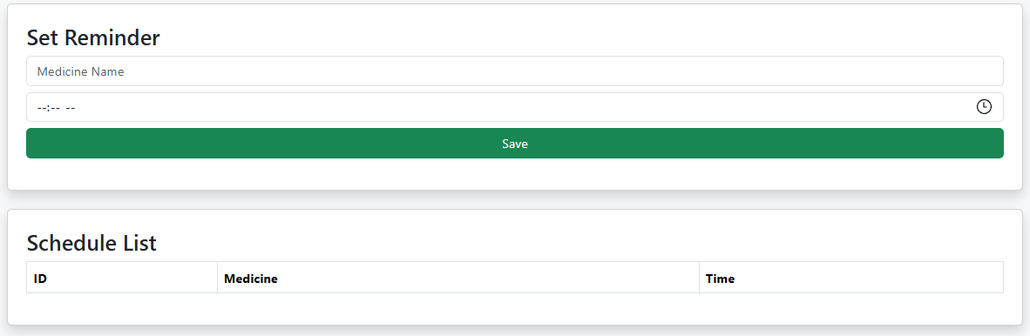

5.Translator Class
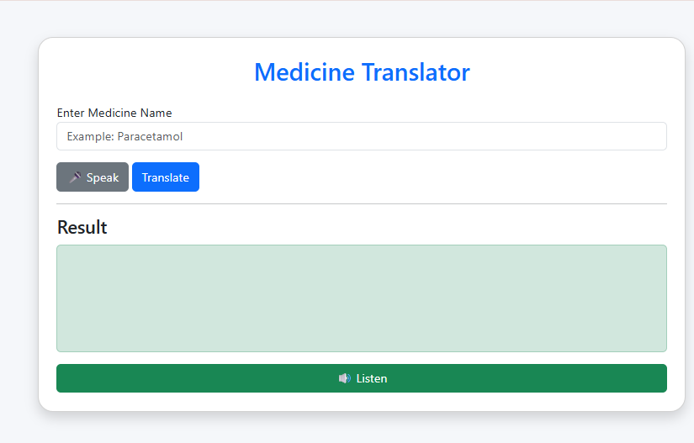

- Buy Class:

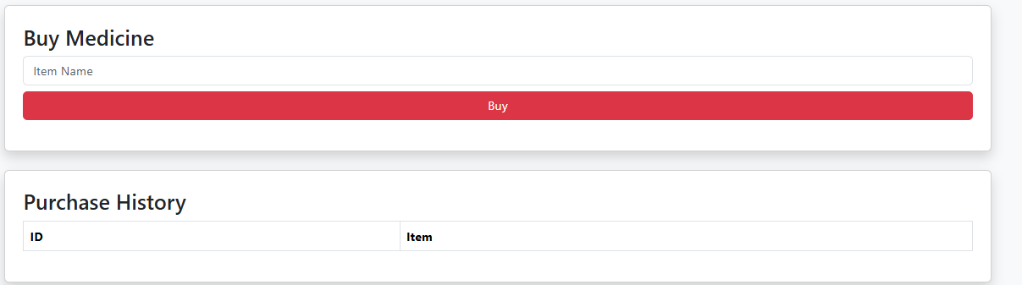
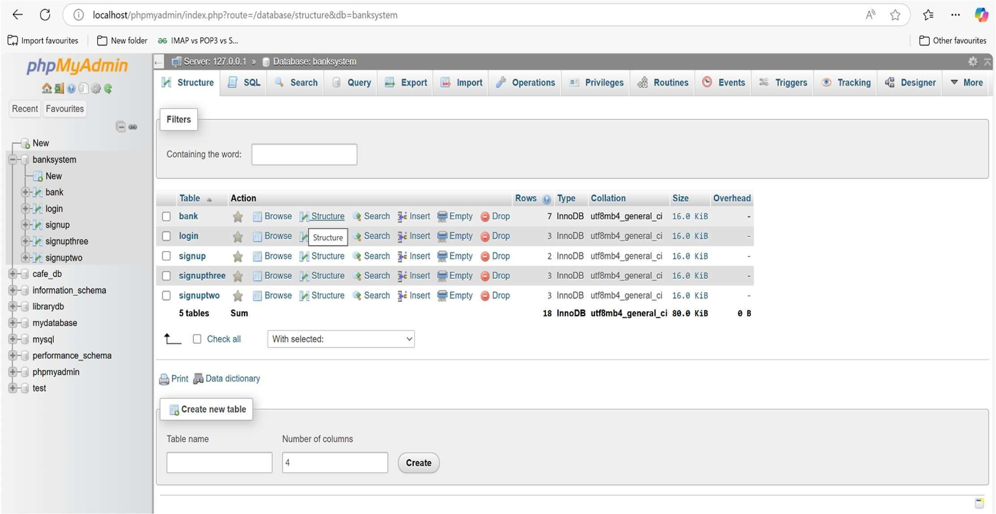

FUTURE SCOPE:
The application can be further improved by integrating:
- AI Chatbot for Healthcare Assistance
- OCR Prescription Scanner
- QR Code Medicine Recognition
- WhatsApp Reminder Integration
- Smartwatch Notifications
- Cloud Database
- Doctor Portal
- Caregiver Monitoring
- Android and iOS Applications

Conclusion

The ElderCare Companion System developed in this project successfully provides a comprehensive platform to assist elderly individuals in managing their daily healthcare activities. The system integrates essential functionalities such as user login, registration, medicine management, scheduling reminders, translation support, purchase tracking, and notification alerts, ensuring a smooth and user-friendly experience.
The application begins with a secure login and registration mechanism, allowing users to safely access their personalized dashboard. Once logged in, users can efficiently manage their medicines, set reminders for timely intake, translate important text for better understanding, and keep track of their medical purchases. The notification system further enhances usability by ensuring that no important task or medication is missed.
Each module of the system is developed using Java technologies such as JSP and Servlets, following object-oriented programming principles like modularity and reusability. The integration with a MySQL database ensures reliable data storage, retrieval, and consistency, reflecting real-world application development practices.
Overall, the project successfully meets its objective of creating a user-friendly and practical healthcare support system. It not only demonstrates the effective use of web technologies but also highlights how software solutions can improve the quality of life for elderly individuals. This system can be further enhanced with advanced features such as real-time notifications, mobile application support, and integration with healthcare services, making it a scalable and impactful solution.

References

- www.github.com
- www.google.com
- www.youtube.com

Github link and Deployment :

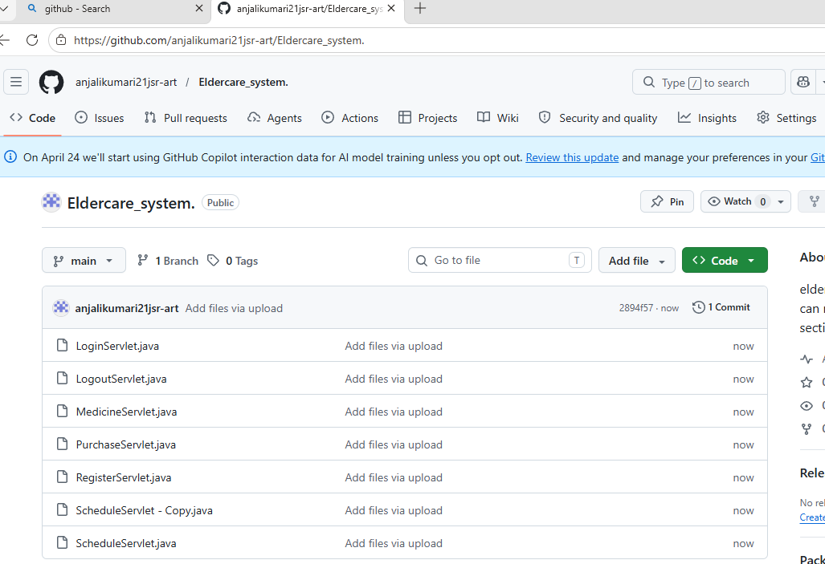

Deployment via Railway:
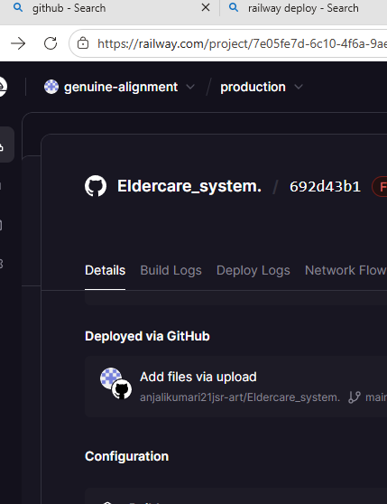

HACKER RANK PROFILE:
